

INFORMATION BRIEF

Updated: December 2022

Reporting period: 01 January to 09 October 2022

**National 2022 Influenza Season Summary**

The Department of Health and Aged Care acknowledges the providers of the many sources of data used in this report and greatly appreciates their contribution.

## KEY MESSAGES

**It is important to note that due to the COVID-19 epidemic in Australia, data reported from the various influenza surveillance systems may not represent an accurate reflection of influenza activity.** **Results should be interpreted with caution, especially where comparisons are made to previous influenza seasons. Interpretation of influenza data from April 2020 onwards should take into account, but are not limited to, the impact of social distancing measures, likely changes in health seeking behaviour of the community including access to alternative streams of acute respiratory infection specific health services, and focussed testing for COVID-19 response activities. For information on COVID-19 incidence, severity, and distribution in Australia, please refer to** [**COVID-19 epidemiology reports**](https://www1.health.gov.au/internet/main/publishing.nsf/Content/novel_coronavirus_2019_ncov_weekly_epidemiology_reports_australia_2020.htm)**.**

Throughout the summary, the seasonal period refers to data from week 18 (week ending 08 May 2022) to week 40 (week ending 09 October 2022), and the reporting period refers to data from 01 January to 09 October 2022. The 5 year average includes data for 2017–2021, and therefore is impacted by the low number of influenza notifications in 2020 and 2021. The low number of influenza notifications in 2020 and 2021 is not expected to impact the proportion of influenza notifications reported as influenza-associated deaths (case fatality rate).

* **Activity –** The 2022 influenza season began earlier compared to recent years.While influenza and influenza-like illness (ILI) activity levels were higher than average across all systems, it was a shorter season with a large peak of laboratory-confirmed influenza notifications in early June. Notifications substantially decreased in July and remained low until the end of the 2022 season.
* **Severity –** The clinical severity for the 2022 influenza season was considered low. In the reporting period, of the 225,332 notifications of laboratory-confirmed influenza, 308 influenza-associated deaths (0.14%) were notified to the National Notifiable Disease Surveillance System (NNDSS).
* **Impact –** Given the high level of influenza activity in the community, it is likely there was low to moderate impact on society during the reporting period.
* **At-risk population –** Children aged 5–9 years had the highest influenza notification rates during the reporting period, followed by children younger than 5 years. The notification rate was lowest among adults aged 70–74 years. Of the 1,832 patients with confirmed influenza admitted to sentinel hospitals, 55.8% were children aged younger than 16 years, 24.3% were adults aged 16 to 64 years, and 19.9% were adults aged 65 years or older.
* **Virology –** During the reporting period, the majority of nationally reported laboratory-confirmed influenza cases were influenza A (82.7%). Influenza B accounted for 0.2% of notifications, less than 0.1% were influenza A and B co-infections, and 17.1% were untyped.
* **Vaccine effectiveness –** Based on preliminary data, the 2022 influenza vaccine significantly reduced the risk of hospitalisation with influenza. Estimated vaccine effectiveness was 44% (95% CI: 22%–60%).

### Introduction

Each year, the influenza virus changes and different strains can circulate in the population. Particular subtypes of influenza can affect different groups of the population more than others. Depending on the susceptibility of the population, the subtypes that are circulating and the changes to the virus itself, the influenza season can be very different year to year. Our surveillance systems help us to understand influenza activity, severity of the infection in individuals and impact of the illness on society in Australia. We are also able to monitor which influenza viruses are circulating, which populations might be more affected, the effectiveness of the vaccine, and any resistance to antiviral drugs that has developed.

### Statement on interpretation of SARS-CoV-2 and influenza co-detection data

This season there were high rates of both SARS-CoV-2 and influenza activity, and it is not surprising that some people will have been infected with both. There is currently no requirement for states and territories to report co-detections of SARS-CoV-2 and influenza nationally. States and territories that have been reporting these data have generally been using the same definition – detection of SARS-CoV-2 and influenza on polymerase chain reaction (PCR) within 7 days of each other.

The following should be considered when interpreting these data:

1. nucleic acid tests (NAT) may detect virus fragments from old, resolved infections and therefore do not necessarily represent active co-infections, but rather co-detections;
2. co-detection of respiratory viruses such as respiratory syncytial virus, adenovirus and human metapneumovirus, is not uncommon, especially in children;
3. co-detection of respiratory viruses is not necessarily an indication of illness severity;
4. when there are high rates of both SARS-CoV-2 and influenza activity, the likelihood of detection of both viruses in a patient presenting for testing increases, and in some cases this will represent co-infection;
5. not everyone with SARS-CoV-2 or influenza will present for testing and therefore will not be captured in reporting;
6. data may not be comparable across jurisdictions due to: differing definitions, laboratory testing policies, and inclusion criteria used (e.g. time period of positive specimens; PCR-positive only, or both PCR and rapid antigen test (RAT) positive results; routine testing for influenza/SARS-CoV-2); and
7. the utility in identifying and reporting on co-detections of SARS-CoV-2 and influenza is primarily for clinical purposes.

The Communicable Diseases Network Australia (CDNA) will continue to monitor emerging evidence about co-infection of SARS-CoV-2 with multiple respiratory pathogens.

For further information on interpretation, please refer to the Data Considerations section within the [Australian Influenza Surveillance Report](https://www.health.gov.au/resources/collections/aisr) and [Technical Supplement – COVID-19 Australia: Epidemiology reporting](https://www1.health.gov.au/internet/main/publishing.nsf/Content/novel_coronavirus_2019_ncov_weekly_epidemiology_reports_australia_2020.htm).

## ANALYSIS

### Activity

Activity measures the capacity of the circulating influenza viruses to spread person to person and may be measured indirectly through systems that monitor influenza-like illness and more directly through systems that monitor laboratory-confirmed influenza.

* During the reporting period, influenza and influenza-like illness activity increased sharply in early May and subsequently peaked in June. Activity remained low since the peak in June.
* Nationally, the average sentinel GP ILI consultation rate for the reporting period in 2022 (4.3 per 1,000 consultations) was 4.4% lower compared to the 5 year average for the same period (4.5 per 1,000 consultations) (Figure 1).
* During the 2022 seasonal period, proportion of FluTracking participants reporting fever and cough first peaked at 2.3% in mid-May (week 19), and again in 2.5% in early July (week 27) (Figure 2). Reports of fever and cough among FluTracking participants were above the 5 year average from early May to early August 2022.
* There were 225,332 notifications of laboratory-confirmed influenza to the National Notifiable Diseases Surveillance System (NNDSS) during the reporting period – almost twice the 5 year average (n=120,745) for this period.
* There were 1,832 admissions with confirmed influenza to sentinel hospitals since surveillance commencement in April 2022 – higher than the 5 year average (n=1,652).
* Influenza circulated at moderate levels throughout the 2022 season. During the seasonal period, 19.9% (136/685) of patients presenting to sentinel GPs with ILI tested positive for influenza.

Figure . ILI presentations to sentinel general practitioners, by week, 2022 and 5 year average, Australia

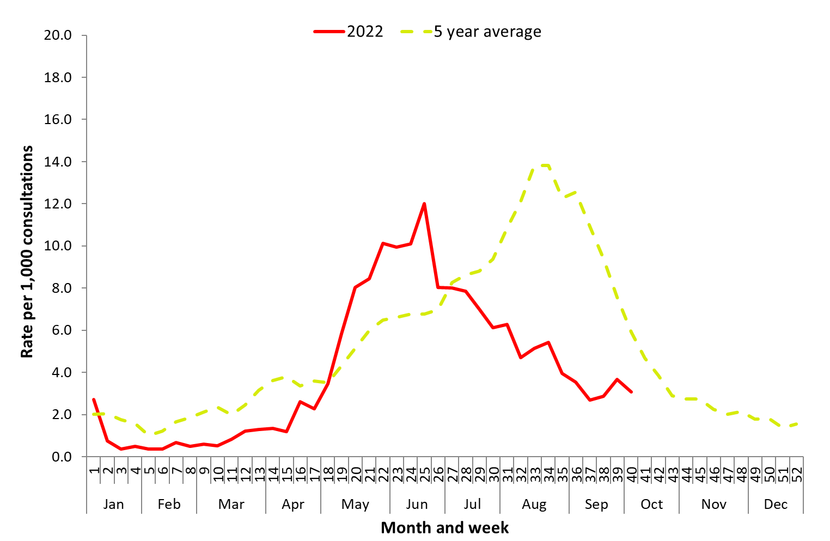

Source: ASPREN

### Severity

Severity is a measure of adverse outcomes or complications as a result of ILI such as hospital referrals, admissions, need for intensive care, and deaths. Measuring and understanding the severity of circulating influenza is difficult to establish at the beginning of, or during a low, influenza season. The proportion of confirmed influenza cases with serious outcomes might be skewed initially because there are only a small number of people notified. This means that the measure of severity will vary substantially fortnight to fortnight until numbers are sufficiently high and there is enough data for measurements to stabilise. An assessment of severity can be provided once the signals become clearer.

* Since surveillance commenced in April 2022, there were 1,832 sentinel hospital admissions, of which 122 (6.7%) were admitted directly to ICU.
* Of the 225,332 notifications of laboratory-confirmed influenza to date in 2022, there were 308 influenza-associated deaths notified to the NNDSS.
  + Over the past five years, the proportion of notified cases who were notified to the NNDSS as influenza-associated deaths (case fatality rate) ranged from 0% in 2021 to 0.48% in 2017, with a 5 year average of 0.37%. The case fatality rate to date in 2022 was 0.14%, notably lower than the 5 year average.
  + The influenza-associated death rate was highest in people aged 85 years and over (24 deaths per 100,000).
  + The majority of notified deaths (99%) were associated with influenza A, of which 84% were influenza A(unsubtyped), 12% were influenza A(H3N2), and 3% were influenza A(H1N1).
  + The median age of deaths notified was 82 years (range: 1–106 years).
  + **Note**: the number of influenza-associated deaths reported to the NNDSS does not represent the true mortality associated with this disease. The number of deaths is reliant on the follow up of cases to determine the outcome of their infection. The follow up of cases is not a requirement of notification and are only inclusive of laboratory-confirmed cases of influenza. Due to retrospective revision, the variation across jurisdictions in methodology, representativeness and timeliness of death data, and reporting an outcome of infection not being a requirement of notification, year on year comparisons of deaths in notified cases of influenza may not be reliable.
* The Australian Bureau of Statistics (ABS) provides an alternative source of influenza mortality data. During the COVID-19 pandemic, the ABS began producing ‘Provisional Mortality Statistics’ reports, which provide data on preliminary counts of doctor certified deaths by date of occurrence for Australia.
  + Note that these data are provisional, and do not include deaths that have been referred to a coroner. More information on the report methodology can be accessed [here](https://www.abs.gov.au/methodologies/provisional-mortality-statistics-methodology/jan-jun-2022).
* As of the most recent Provisional Mortality Statistics report (reporting period 01 January 2022 to 30 June 2022), there were 193 deaths due to influenza in 2022. Of the 193 deaths due to influenza, 76% were certified in June 2022, coinciding with peak influenza activity in Australia.1
  + Note that the number of deaths caused by influenza captured in ABS datasets may differ from the number of influenza-associated deaths reported to the NNDSS. This may be due to deaths caused by influenza captured in ABS datasets that may not meet the [NNDSS influenza case definition](https://www.health.gov.au/resources/publications/influenza-laboratory-confirmed-surveillance-case-definition), and due to reasons detailed above regarding underrepresentation of the true mortality associated with this disease in the NNDSS.

### Impact

Impact measures how influenza affects society, including stress on health-care resources and societal and economic consequences.

* Given the high level of influenza activity in the community in 2022, it is likely that there was low to moderate impact on society, and the healthcare system, as a result of circulating influenza during the 2022 season.
* During the 2022 seasonal period, 1.6% (weekly average) of FluTracking participants reported having fever and cough, with 1.3% (weekly average) of all participants reporting time off regular duties while unwell with fever and cough. This was above the 5 year historical weekly averages of 1.3% of participants reporting fever and cough, and 0.9% of participants taking time off regular duties while experiencing fever and cough (Figure 2).

Figure . Proportion of (i) fever and cough, and (ii) fever, cough and absence from normal duties among FluTracking participants, Australia, 2022 and 5 year average, by month and week*#

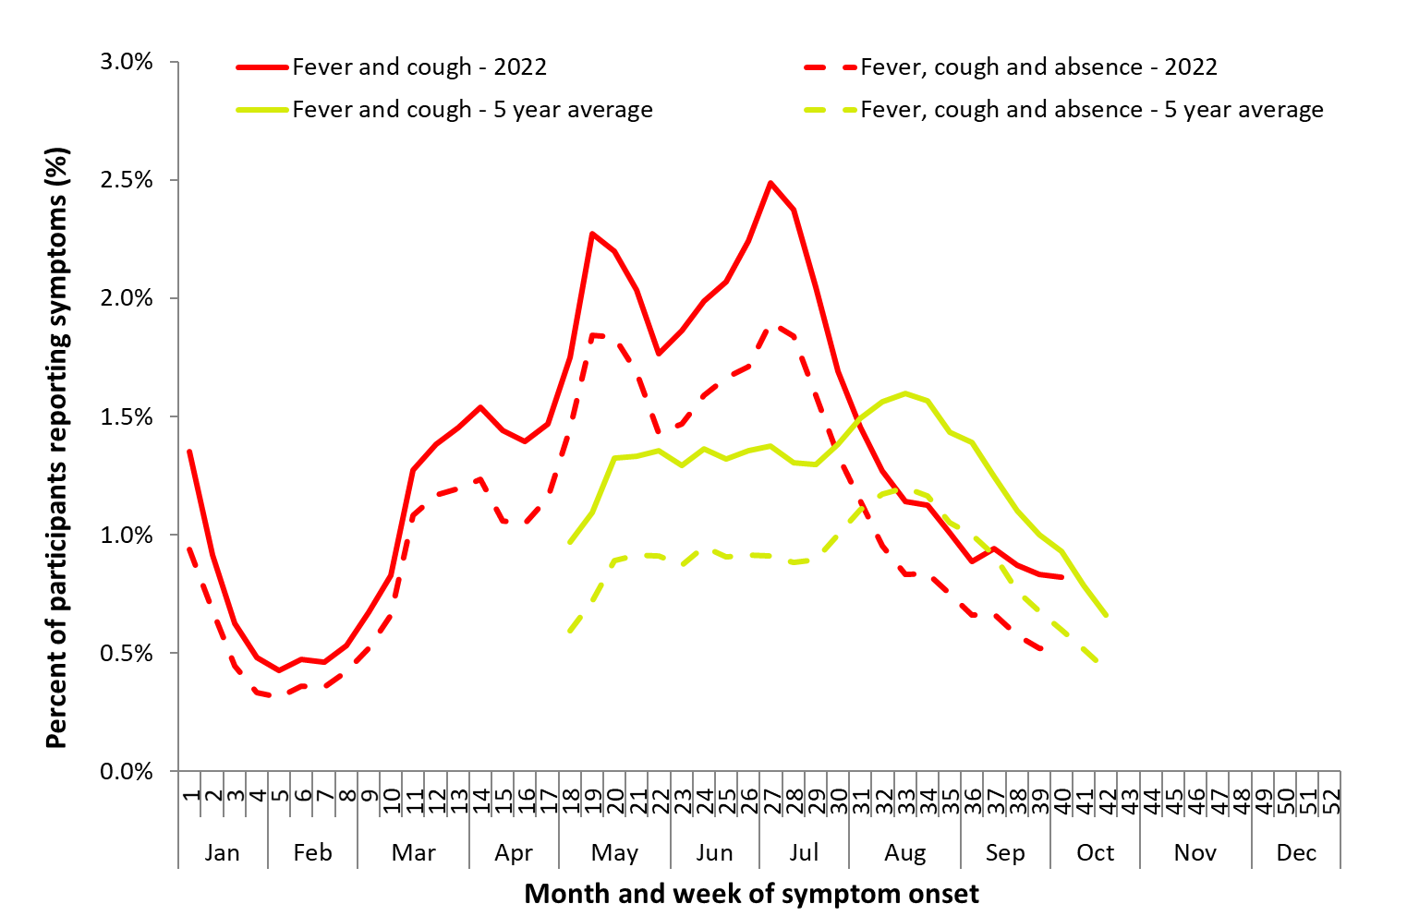

Source: FluTracking

*All data are preliminary and subject to change as updates are received, with most recent weeks considered particularly subject to revisions.

#FluTracking have expanded their reporting period from 2020 onwards due to COVID-19. As such, 5 year historical comparisons are not available for data reported before May and after October for any year before 2020. Please refer to Data considerations for interpretation of the 5 year average.

### Geographical variations

* During the reporting period, influenza notifications peaked in 5/8 jurisdictions in weeks 24–25. Victoria peaked in week 21, the Northern Territory peaked in week 22, and Western Australia peaked in week 27.
* During the reporting period, the influenza notification rates were highest in the Northern Territory (1,933 per 100,000 population), New South Wales (1,387 per 100,000 population), and Queensland (816 per 100,000 population).
* There were variations across jurisdictions in the influenza type and subtype distribution, with the proportion of all notifications reported as influenza A varying across jurisdictions. This ranged from 60.0% in the Australian Capital Territory to 99.9% in Tasmania.
  + Subtyping information was not available for all laboratory-confirmed influenza notifications (See Virology section below), but where subtyping information was available, all jurisdictions reported a greater proportion of influenza A(H3N2) than A(H1N1).
  + Influenza B was rarely detected.

### At-risk populations

At-risk populations are people who may be more susceptible to infection with the influenza virus and/or who may be more likely to experience severe outcomes from their infection.

* Notification rates during the reporting period have been relatively consistent with previous years with high notification rates among children. Notification rates in older adults aged 75 years or older were not as high as those observed in years 2017 and 2019.
  + To date in 2022, notification rates were highest in people aged 5–9 years (2,154 notifications per 100,000 population), followed by children aged younger than 5 years (1,859 notifications per 100,000 population), and people aged 10–14 years (1,463 per 100,000 population).
  + To date in 2022, notification rate was lowest among adults aged 70–74 years (320 notifications per 100,000 population), followed by adults aged 65–69 years (335 notifications per 100,000 population).
* To date in 2022, influenza-associated death rate was highest in people aged 85 years and over (24 deaths per 100,000). This is consistent with trends observed in the previous five years (2017–2021).
* Of the 1,832 patients with confirmed influenza admitted to sentinel hospitals, 55.8% were in children aged younger than 16 years, 24.3% were adults aged 16 to 64 years, and 19.9% were adults aged 65 years or older.
  + Of children aged younger than 16 years admitted with confirmed influenza to date, 5.9% were admitted directly to ICU, compared to 10.6% of adults aged 16 to 64 years, and 4.1% of adults aged 65 years or older.
  + Medical comorbidities were reported in 53% (977/1,832) of cases admitted to sentinel hospitals.

### Virology

* During the reporting period, 82.7% of laboratory-confirmed influenza notifications reported to the NNDSS influenza A, of which 94.4% were influenza A(unsubtyped), 4.7% were influenza A(H3N2), and 0.9% were influenza A(H1N1). Influenza B accounted for 0.2% of notifications, less than 0.1% were influenza A and B co-infections, and 17.1% were untyped.
* Of the 2,570 samples characterised by the WHOCC between 01 January and 09 October 2022, 78.7% (n=2,023) were influenza A(H3N2), 21.1% (n=541) were influenza A(H1N1), and less than 1% (n=6) were influenza B/Victoria.
* Of the 2,570 isolates characterised by the WHOCC, 92.4% of influenza A(H1N1) isolates, 94.5% of influenza A(H3N2) isolates and all six influenza B/Victoria isolates were antigenically similar to the corresponding vaccine components.

### Vaccine match and effectiveness

Vaccine effectiveness is a measure of the protective effect of influenza vaccines against influenza and its complications and is typically around 40–60%. This means that vaccinated individuals are roughly 40–60% less likely to get influenza or severe influenza than unvaccinated people. It is monitored by several sentinel influenza surveillance systems in Australia. This varies from season-to-season based on the match between vaccine strains and circulating strains of influenza.

* Preliminary vaccine effectiveness (VE) estimates are based on incomplete data and the final season estimates may differ.
* Based on preliminary estimates from sentinel hospitals (FluCAN), the 2022 influenza vaccine significantly reduced the risk of hospitalisation with influenza. Estimated VE was 44% (95% CI: 22%–60%).
* The overall combined preliminary estimate from sentinel GPs (ASPREN and VicSPIN) was 37% (95%CI: -13%–66%) for both influenza A and B.
  + The vaccine appeared to be most effective in adults aged 18–64 years, at 61% (95% CI: 22%–82%), especially in those testing positive for H3N2 (66%, 95% CI: 26%–85%).

### Antiviral Resistance

* Of the influenza A(H1N1) samples tested for neuraminidase inhibitor resistance, 1% (n=2) demonstrated reduced inhibition to Oseltamivir. None of the influenza A(H3N2) or influenza B/Victoria samples tested for neuraminidase inhibitor resistance demonstrated reduced inhibition to either Oseltamivir or Zanamivir.

### Data considerations and further information

**NNDSS laboratory-confirmed influenza surveillance case definition**—From 01 January 2022, the [NNDSS surveillance case definition for laboratory-confirmed influenza](https://www.health.gov.au/resources/publications/influenza-laboratory-confirmed-surveillance-case-definition) was updated to remove Point 5 ‘Single high titre by complement fixation test (CFT) or haemagglutination inhibition (HAI) to influenza virus’ from the list of laboratory definitive evidence. This change has minimal impact on the interpretation of influenza notification trends, with the change ensuring consistency with the influenza laboratory case definition. For further information, please refer to the [NNDSS laboratory-confirmed influenza case definition Technical Supplement](https://www.health.gov.au/resources/publications/technical-supplement-2022-update-to-nndss-laboratory-confirmed-influenza-case-definition).

Data in this summary is reported by International Organization for Standardization (ISO) 8601 weeks, with the week ending on Sunday. Throughout the summary, where the year to date is presented, this includes data from 01 January to 09 October 2022. NNDSS data is analysed and reported based on diagnosis date, which is the true onset date of a case if known, otherwise it is the earliest of the specimen date, the notification date, or the notification received date. NNDSS data were extracted on 11 October 2022.

In interpreting these data, it is important to note that changes in notifications over time may not solely reflect changes in disease prevalence or incidence. Depending on the disease, the number of notifications may be influenced by changes in testing policies; changes in case definitions; changes in testing practices and screening programs; the use of less invasive and more sensitive diagnostic tests; and periodic awareness campaigns. In particular, analyses including data from 2020 should be interpreted with caution. In 2020, there was a significant decrease in influenza and ILI activity related to the COVID-19 pandemic and associated public health measures. Data from 2020 may reduce 5 year averages and affect usual seasonal trends. In some circumstances, comparison to data in years prior to 2020 may be more relevant.

Due to the dynamic nature of the NNDSS and other surveillance systems, data in this report are subject to retrospective revision and may vary from data reported in other national reports and reports by states and territories. Detailed notes on interpreting the data presented in this report are available at the Department of Health and Aged Care’s [Australian Influenza Surveillance Report website](http://www.health.gov.au/flureport) (www.health.gov.au/flureport). While every care has been taken in preparing this report, the Commonwealth does not accept liability for any injury or loss or damage arising from the use of, or reliance upon, the content of the report. Delays in the reporting of data may cause data to change retrospectively. For further details about information contained in this report please contact the [Influenza Surveillance Team](mailto:flu@health.gov.au) ([flu@health.gov.au](mailto:flu@health.gov.au)).

For further information regarding influenza activity at the jurisdictional level, please refer to the following State and Territory health surveillance reports:

* ACT: [ACT Influenza Report](https://www.health.act.gov.au/about-our-health-system/population-health/winter-wellbeing-and-flu/flu-act) (www.health.act.gov.au/about-our-health-system/population-health/winter-wellbeing-and-flu/flu-act)
* NSW: [Respiratory surveillance reports](https://www.health.nsw.gov.au/Infectious/covid-19/Pages/weekly-reports.aspx) (https://www.health.nsw.gov.au/Infectious/covid-19/Pages/weekly-reports.aspx)
* QLD: [Statewide Weekly Influenza Surveillance Report](https://www.health.qld.gov.au/clinical-practice/guidelines-procedures/diseases-infection/surveillance/reports/flu) (https://www.health.qld.gov.au/clinical-practice/guidelines-procedures/diseases-infection/surveillance/reports/flu)
* SA: [Weekly Epidemiological Summary](http://www.sahealth.sa.gov.au/wps/wcm/connect/public+content/sa+health+internet/about+us/health+statistics/surveillance+of+notifiable+conditions) (Influenza section) (http://www.sahealth.sa.gov.au/wps/wcm/connect/public+content/sa+health+internet/about+us/health+statistics/surveillance+of+notifiable+conditions)
* TAS: [fluTAS Reports](https://www.health.tas.gov.au/health-topics/flu-influenza/flutas-reports) (https://www.health.tas.gov.au/health-topics/flu-influenza/flutas-reports)
* VIC: [Influenza Surveillance Reports](https://www2.health.vic.gov.au/public-health/infectious-diseases/infectious-diseases-surveillance/seasonal-influenza-reports) (https://www2.health.vic.gov.au/public-health/infectious-diseases/infectious-diseases-surveillance/seasonal-influenza-reports)
* WA: [Virus WAtch](http://ww2.health.wa.gov.au/Articles/F_I/Infectious-disease-data/Virus-WAtch) (<http://ww2.health.wa.gov.au/Articles/F_I/Infectious-disease-data/Virus-WAtch>)

### Reference

1. Australian Bureau of Statistics. Provisional Mortality Statistics. [Internet.] Canberra: Australian Bureau of Statistics; 2022. [Accessed on 20 October 2022.] Available from: <https://www.abs.gov.au/statistics/health/causes-death/provisional-mortality-statistics/jan-jun-2022>.