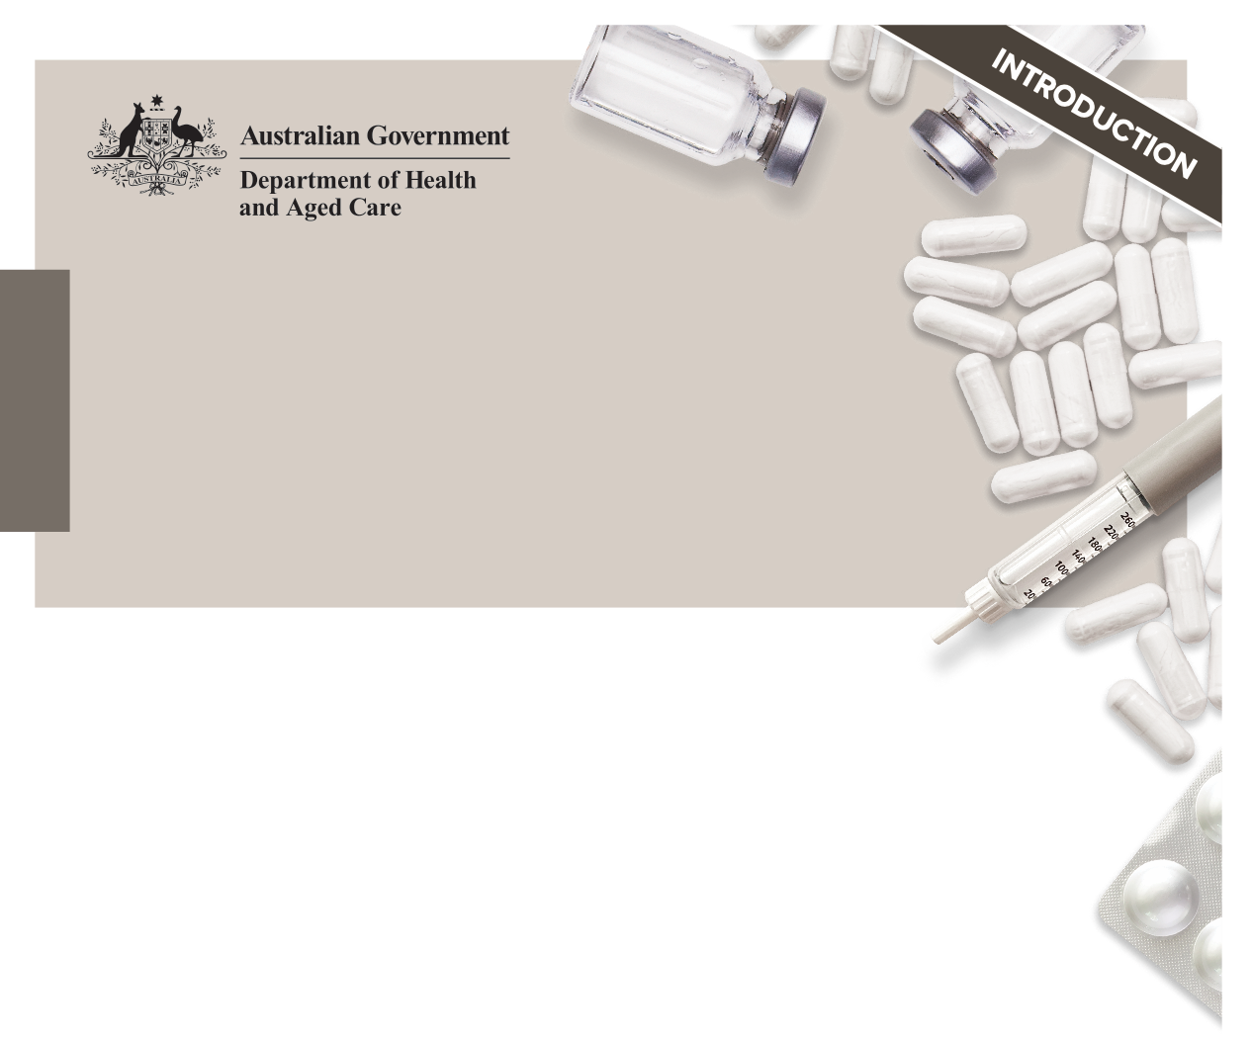The 2022 editions of the national quality use of medicines publications

# The publications

In 2021, the Australian Government Department of Health and Aged Care, engaged the Australian Commission on Safety and Quality in Health Care to review and update the national quality use of medicines (QUM) publications in consultation with stakeholders. The 2022 editions of the national QUM publications (see **Figure 1**) are available on the Department of Health and Aged Care’s [website](http://www.health.gov.au):

* [Guiding Principles to Achieve Continuity in Medication Management](http://www.health.gov.au)
* [Guiding Principles for Medication Management in the Community](http://www.health.gov.au)
* [Guiding Principles for Medication Management in Residential Aged Care Facilities](http://www.health.gov.au) and its ‘supplement’ [User Guide: Role of a Medication Advisory Committee](http://www.health.gov.au)
* [Glossary for the Guiding Principles and User Guide](http://www.health.gov.au).

# Purpose and scope

The 2022 editions of the three Guiding Principles publications individually build on their previous editions and are underpinned by [Australia’s National Medicines Policy](https://www.health.gov.au/resources/publications/national-medicines-policy).

The national QUM publications are closely related and:

* Promote practice that keeps the individual receiving care at the centre of an integrated health system
* Advocate a person-centred partnership and systems approach to achieve safe and quality use of medicines and medication management within residential aged care facilities, the community and at all care transitions, and
* Highlight that sound governance of medication management is fundamental to QUM at all steps along the medication management pathway.

Figure 1: The 2022 editions of the national quality use of medicines publications

Images of the five covers of the 2022 editions of the national quality use of medicines publications


It is recommended that users of any one of the national QUM publications should be aware of and refer to the other publications as needed. The relationship between the three publications can be seen in **Figure 2**, as well as providing a summary of an individual’s medication management journey during transitions of care.

Three fact sheets are also available on the Department of Health and Aged Care’s [website](http://www.health.gov.au), and provide summary information about the national QUM publications:

* Fact sheet: Guiding Principles to Achieve Continuity in Medication Management
* Fact sheet: Guiding Principles for Medication Management in the Community
* Fact sheet: Guiding Principles for Medication Management in Residential Aged Care.

# How to use these publications

Each of the three Guiding Principles publications includes:

* A statement of each Guiding Principle with a summary and intent
* Key terms – with background, context and additional information
* Action items for the providers of healthcare services, the healthcare professional(s) and the individual, their carer and/or family.

A consolidated list of suggested resources is also included for each Guiding Principle.

Each Guiding Principle should be read in conjunction with the supporting information, which includes further explanation of each principle and information to support its implementation – such as examples and references for practice settings.

Figure 2: The medication management journey during transitions of care

Figure 2: The medication management journey during transitions of care

Individual’s* home: 
The individual*, their carer and/or family:
• Hold and share a current list of all their medicines with healthcare service providers/healthcare professionals (for example, via My Health Record)
• Provide informed consent for medicines treatment, assessments, and/or medication reviews
• Has all the medicines and information they need to take their medicines safely, and if possible, to self-manage symptoms and/or report adverse effects
• Is able to maximise their independence with or without assistance in their home (for example, dose administration aids or reminders; care workers)

Community healthcare providers:
• Medication review is documented in the medication management plan by the healthcare professional, using digital strategies, and made accessible to others involved in providing care. Consent is also documented
• Healthcare professionals prescribe and dispense medicines, and organise dose administration aids 
• Counselling accompanies the provision of tailored information about medicines

Hospital: 
Medicines are reconciled and reviewed, and medicines-related information are shared and discussed with the individual*, their carer and/or family by the healthcare team at all transitions of care

Residential Aged Care Facility: 
• Medication reconciliation and review are documented and used to inform:
 – The medication management plan
 – Which medicines are prescribed on the medication chart (hardcopy or electronic) 
• Records of assessments and consent to medicines treatment are maintained – for example, for medication review, the ability to swallow and/or self-administer medicines safely and/or use of dose administration aids

An arrow = Common pathway
A dashed arrow = Less common pathway (for example, respite care)

In all pathways, the healthcare professional is responsible for the sharing of timely, accurate and complete medicines information about the individual receiving care. The individual*, their carer and/or family have an active partnership role in all these pathways.

*The individual depicted is an image of an older person, however they are representative of the range of individuals that may transition between healthcare services or environments.
