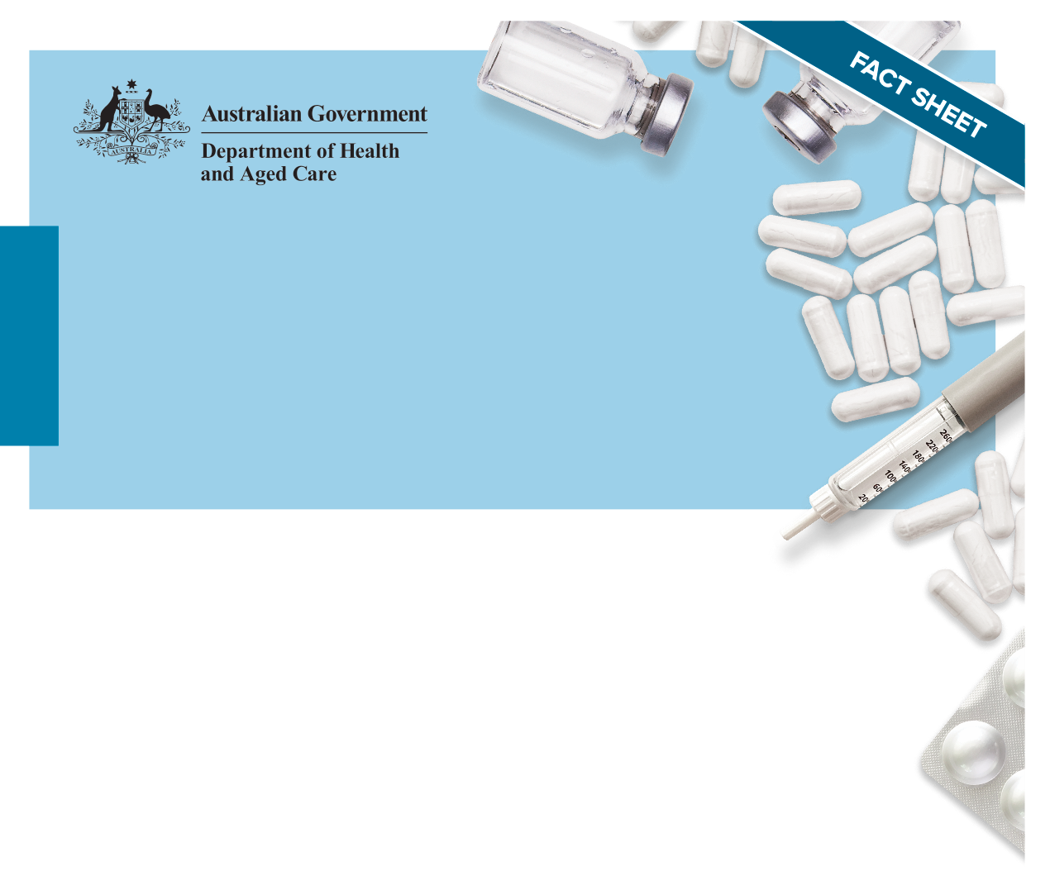National quality use of medicines

Medication management in the community

Guiding principles

# Purpose and scope

The [Guiding Principles for Medication Management in the Community](http://www.health.gov.au) (the Guiding Principles) promote practice that keeps the individual receiving care at the centre of an integrated health system. They advocate a person-centred partnership and systems approach to achieve safe and quality use of medicines (QUM) and medication management in the community. The Guiding Principles are intended to:

* Assist community healthcare service providers in developing or evaluating policies, procedures and guidelines
* Support those involved in assisting people in their homes
* Support people in managing their own medicine(s)
* Guide healthcare professionals when applying and evaluating professional practice standards or guidelines.

These the Guiding Principles build on the 2006 edition of the guiding principles and are underpinned by [Australia’s National Medicines Policy](https://www.health.gov.au/resources/publications/national-medicines-policy).

The Guiding Principles are to be applied by all providers of healthcare services and healthcare professionals involved in medication management and the individual (and/or their carer) receiving care in the community. They are applicable across all age groups and may be particularly useful in the medication management of people on multiple medicines.

# The Guiding Principles – a summary

The following summary includes the heading and statement for each Guiding Principle. A selection of key tasks are also included for community healthcare service providers, healthcare professionals, and/or the individual, their carer and/or family to action. Guiding Principles 1–3 set the overarching requirements for the effective implementation of the remaining Guiding Principles 4–12.

## Person-centred care

All those involved in a person’s medicines management provide person-centred care. This includes respect, emotional support, physical comfort, information and communication, continuity and transition, care coordination, informed consent and involvement of a person’s carer and/or family. People have the right to partner in their care to the extent that they choose.

### Key task

To apply this overarching Guiding Principle when implementing the [Guiding Principles for Medication Management in the Community](http://www.health.gov.au).

## Communicating about medicines

All medicines-related communications consider health literacy, are ‘person-centred’ and collaborative, and facilitate shared decision-making, advocacy and selfdetermination.

### Key task

To apply this overarching Guiding Principle when implementing the [Guiding Principles for Medication Management in the Community](http://www.health.gov.au).

## Governance and risk management of medicines use in the community

Healthcare professionals, care workers and service providers work together with individuals and/or their carers to prevent and/or manage risks, incidents and adverse reactions associated with medicines use in the community.

### Key tasks

For all those involved in medication management in the community to:

* Report medication incidents and/or adverse effects
* Encourage, support, document and respond to concerns or complaints about medicines from those receiving care, their carer and/or family.

## Information resources

All those involved with the prescribing, dispensing, administration, and handling of medicines in the community should have access to current and evidence-based medicines-related information tools and resources.

People, their carers and/or families should also have access to plain language, accurate, evidence-based, trusted and reliable medicines-related information.

### Key task

For all healthcare professionals to access, refer to and/or use the most up-to-date and evidence-based medicines-related information, decision support tools and resources in all aspects of care delivery and shared decision-making.

## Self-administration of medicines

People are encouraged to have an active role and have the right to make choices and decisions about their care, and where necessary, are supported to maintain maximum independence for as long as possible. This includes managing their own medicines in a safe and effective way.

### Key task

To apply a collaborative approach to addressing issues regarding self-administration of medicines to ensure an individual can safely manage their medicines at home.

## Dose-administration aids

Dose administration aids (DAAs) should be used to support individuals to remain independent and reduce the risk of administration error. They should only be used when a person is assessed as having a specific problem managing or safely administering their own medicines.

### Key task

To ensure that informed consent is obtained when a person is to be supplied their medicines packed in a DAA, and that only those medicines that are suitable are packed in the DAA.

## Administration of medicines in the community

People who live at home should have access to, and receive, suitable information and/or assistance so that they can take their medicines safely and effectively. Healthcare professionals, care workers and healthcare service providers all play an important role.

### Key task

To ensure medicines administration practices and assistance by care workers (however titled) are in accordance with legislation, professional and regulatory requirements, and the community healthcare service provider’s medicines administration policies, procedures and guidelines.

## Medicines list

Everyone taking one or more medicines should be encouraged and supported to maintain an uptodate list of all their medicines. This list should be available and easily accessible to the individual and all those involved in their care.

### Key tasks

* For individuals to inform their prescribers, pharmacists and nurses about all the medicines they are taking
* For healthcare professionals to reconcile and ensure an individual’s own medicines-related records, such as the My Health Record and medicines list, are up to date.

## Medication review

A person has the right for their medicines to be routinely and regularly reviewed with members of their healthcare team. These reviews should be conducted in accordance with relevant professional responsibilities, practice standards and guidelines.

### Key tasks

* For all medicines to be reviewed regularly by the relevant healthcare professional and documented in the medication management plan, and that the process is collaborative between the individual, their carer and/or family as well as other relevant members of the healthcare team
* For individuals to be provided and/or have access to information about the range and purpose of medication review services that are available to them.



## Alteration of solid oral dose forms

Alteration of oral dose forms of medicines, such as crushing tablets, should be avoided. However, if a person is suffering from swallowing difficulties:

* Suitable alternative formulations (or medicines) should be sought
* The person should be provided with the information and help they need to ensure their medicines can be administered safely and effectively.

## Storage and disposal of medicines

All those using medicines in the community should store medicines in a manner that:

* Maintains the quality of the medicines
* Minimises wastage
* Safeguards the person, the person’s family and visitors in their home.

Unwanted, ceased or expired medicines should be disposed of safely to avoid accidental harm and misuse in a sustainable and environmentally appropriate manner.

## Authorised initiation of medicines in the community

In accordance with national, state or territory legislation, only those authorised to do so should initiate medicines upon a person’s request for the relief of minor symptoms or conditions/ailments.

Healthcare service providers should develop policies, procedures and guidelines on:

* Initiation of prescription and non-prescription medicines
* Use and review of prescription medicines treatment protocols.

### Key task

To ensure authorised initiation of medicines is in accordance with legislation, professional and regulatory requirements.