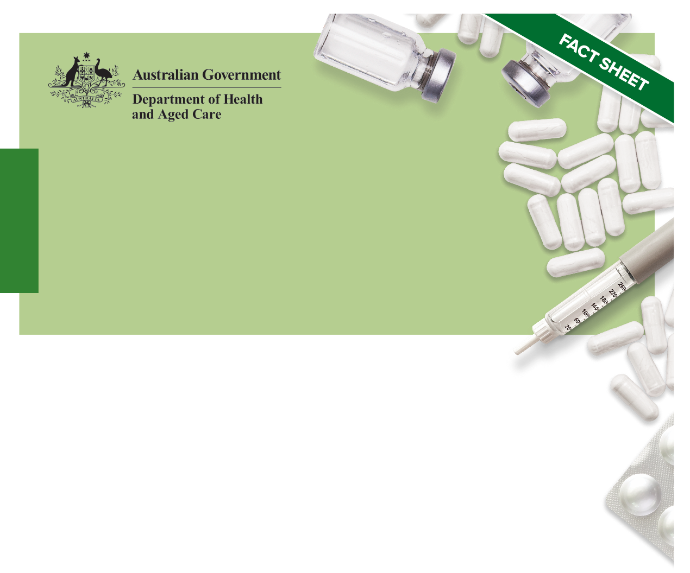National quality use of medicines

Medication management in residential aged care facilities

Guiding principles

# Purpose and scope

The [Guiding Principles for Medication Management in Residential Aged Care Facilities](http://www.health.gov.au) (the Guiding Principles) are intended to promote practice that keeps the individual receiving care at the centre of an integrated health system. They advocate a person-centred partnership and systems approach to achieve safe and quality use of medicines (QUM) and medication management within residential aged care facilities (RACFs). Sound governance of medication management is fundamental.

These Guiding Principles build on the 2012 edition of the guiding principles and are underpinned by [Australia’s National Medicines Policy](https://www.health.gov.au/resources/publications/national-medicines-policy).

A [User Guide: Role of a Medication Advisory Committee](http://www.health.gov.au) (User Guide) is also available as a ‘supplement’ to these Guiding Principles and aims to assist RACFs to either implement a medication advisory committee (MAC) or optimise an existing MAC.

The Guiding Principles and User Guide are to be applied by all providers of residential aged care services and healthcare professionals involved in medication management and the individual (and/or their carer) receiving care within RACFs.

# The Guiding Principles – a summary:

The following summary includes the heading and statement for each Guiding Principle. A selection of Key tasks are also included for the RACF, the healthcare workforce, and/or the individual, their carer and/or family to action. Guiding Principles 1–4 set the overarching requirements for the effective implementation of the remaining Guiding Principles 5–15.

## Person-centred care

All those involved in a person’s medicines management provide person-centred care. This includes respect, emotional support, physical comfort, information and communication, continuity and transition, care coordination, informed consent and involvement of a person’s carer and/or family. People have the right to partner in their care to the extent that they choose.

### Key task

To apply this overarching Guiding Principle when implementing the [Guiding Principles for Medication Management in Residential Aged Care Facilities](http://www.health.gov.au).

## Communicating about medicines

All medicines-related communications consider health literacy, are ‘person‑centred’ and collaborative, and facilitate shared decision-making, advocacy and self‑determination.

### Key task

To apply this overarching Guiding Principle when implementing the [Guiding Principles for Medication Management in Residential Aged Care Facilities](http://www.health.gov.au).

## Clinical governance of medication management

The RACF has systems and processes that are used to support and promote safe and effective management of the quality use of medicines within the facility.

### Key task

For the RACF to refer to the [User Guide: Role of a Medication Advisory Committee](http://www.health.gov.au) and assign the governance of medication management to a relevant committee within the RACF’s governance framework. **Figure 1** summarises the priority areas for action within a medicines governance framework.

Figure : Priority areas for action

Figure 1: Priority areas for action

Support and promote a safe interdisciplinary medication management system

Use incident analysis to understand key risks within the RACF and target strategies for improvement

Use Continuous Quality Improvement (CQI) methods to understand and improve medication management processes

Use tools and indicators to help target actions for improvement and evaluate or monitor 
progress

Build knowledge and ability to take action

## Evaluations and quality improvement in medication management

The RACF routinely reports on the mandatory medication management indicators and regularly reviews, identifies and evaluates risk within each area of medication management, taking follow-up action where required.

### Key tasks

For the RACF to establish an environment that fosters continuous quality improvement in medication management including the:

* Reporting and analysis of information/data from various sources such as the   
  [National Aged Care Mandatory Quality Indicator program](https://www.health.gov.au/initiatives-and-programs/national-aged-care-mandatory-quality-indicator-program-qi-program) and [Serious Incident Response Scheme](https://www.agedcarequality.gov.au/sirs)
* Development of internal quality improvement strategies as needed.

## Information resources

The RACF ensures access to the most current and evidence-based medicines‑related information, tools and resources for each person receiving care, their carers, the RACF healthcare team and visiting healthcare providers.

### Key task

For all healthcare professionals to access, refer to and/or use the most up-to-date and evidence-based medicines-related information, decision support tools and resources in all aspects of care delivery and shared decision-making.

## Selection of medicines

The RACF supports informed evidence-based decision-making for the selection of medicines used within the facility.

### Key task

For the RACF to ensure existing processes for the selection of medicines used within the facility, reflect and support a QUM approach.

## Complementary and self-selected non-prescription medicines

The RACF supports informed selection and safe use of complementary and self-selected non‑prescription medicines for each person receiving care.

### Key tasks

For health professionals to:

* Encourage the individual receiving care (supported by their carer and/or family) to inform them about their use of complementary and non-prescription medicines, and ensure they have access to evidence-based information on these medicines
* Document and administer complementary and self-selected non-prescription medicines in the same manner as prescription medicines.

## Authorised initiation of medicines by nurses

Where deemed appropriate, the RACF has policies, procedures and guidelines, endorsed by the RACF’s MAC, in place to allow the authorised:

* Initiation of non-prescription medicines from an approved list
* Use and review of prescription medicine treatment protocols.

### Key task

For the RACF to ensure that authorised initiation of medicines by nurses is in accordance with legislation, professional and regulatory requirements.

## Documentation of medication management

To support safe prescribing, dispensing and administration of each person’s medicines and effective communication of their medicines-related information, the RACF ensures that a current, accurate and reliable record of all medicines selected, prescribed and used is documented on their medication chart (paper‑based or electronic).

### Key task

For the RACF looking to implement an electronic medication management (eMM) system, to consider medication management workflows, legislative requirements, and change management planning, and ensure the eMM system is fit for purpose.

## Medication reconciliation

Medication reconciliation processes are used within RACFs to:

* Verify a person’s medication history
* Reduce the risk of errors in medicines documentation when care is transferred, or new medicines are prescribed
* Ensure all medicines are ordered and received as intended.

### Key task

For the RACF to review its medication management policies, procedures and guidelines to ensure they outline the range of healthcare professionals that can complete medication reconciliation, when it should occur, and that verified information is shared to support ongoing care.

## Medication review

The RACF healthcare team and visiting healthcare providers ensure that each person’s medicines are reviewed regularly and as needed, to optimise medicines use and minimise medicines‑related problems.

### Key task

For the RACF to ensure that there is a mechanism to identify people in their care that are at most risk of, or have suffered, a medicines-related problem, and that they are prioritised for medication review.

## Continuity of medicine supply including in an emergency

The RACF minimises interruptions to medicines supply and maintains timely access to medicines for each person receiving care. This may include having access to a curated emergency stock of medicines.

### Key task

For the RACF to ensure that medication management policies, procedures and guidelines are in place to support continuity of medicines supply for people receiving care and that the stocking of an emergency supply of medicines is in accordance with the relevant state or territory legislation.

## Storage and disposal of medicines

The RACF ensures that:

* All medicines, including self-administered medicines, are stored and handled safely and securely, and in a manner that maintains the quality of the medicines
* Unwanted, ceased or expired medicines are disposed of safely to avoid accidental harm and misuse.

Disposal of medicines aligns with sustainable and environmental best practice.

### Key task

For the RACF to review existing policies, procedures and guidelines on the storage and disposal of medicines to ensure they include:

* Effective early detection and response to problems – for instance, refrigerator temperature excursions
* Specific requirements for waste segregation and appropriate arrangements for medicines disposal.

## Self-administration of medicines

The RACF:

* Supports and seeks informed consent from individuals who wish to administer their own medicines
* Ensures policies, procedures and guidelines are in place to guide the assessment and re-assessment of a person’s capacity to self-administer medicines safely.

### Key task

For healthcare professionals involved in the assessment of an individual for self-administration of medicines to:

* Consider their capacity to do so safely using a ‘dignity of risk’ plan approach
* Regularly review or reassess their willingness and ongoing capacity, especially when the individual experiences a change in their health or cognitive status.

## Administration of medicines by nurses

Each RACF ensures it has policies, procedures and guidelines in place that are endorsed by the RACF’s MAC, to guide the safe and effective administration of medicines by appropriately qualified and authorised nurses.

### Key task

For the RACF to ensure that medicines administration practices are in accordance with legislation, professional and regulatory requirements, and the RACF’s medicines administration policies, procedures and guidelines.