

# ACFI Monitoring report - September 2022

## Summary

* Average ACFI claims remained steady in September.
* The solid line in Figure 1 shows the average daily claim rate.
* The impact of the temporary increase in subsidies in the March 2019 quarter is highlighted in the dotted line, while the dashed line shows the impact of temporary funding increase from 1 March 2020 in response to the COVID-19 pandemic.
* The remainder of this report provides analysis based on the changes in claim rates without the temporary increase incorporated.

Figure . Average daily ACFI claim per month[1]

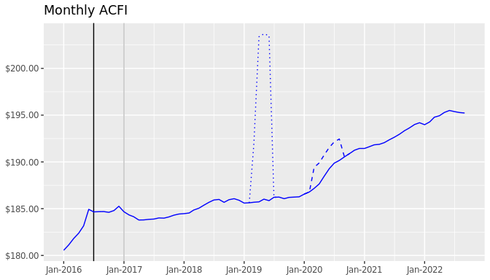

Table : Cumulative Daily Average ACFI Subsidies and Growth Rates by ACFI Category

| ACFI category | July 2021 to Sep 2021 | July 2022 to Sep 2022 | Nominal growth | Real growth |
| --- | --- | --- | --- | --- |
| ADL | $102.56 | $105.48 | 2.8% | 1.1% |
| BEH | $30.23 | $31.25 | 3.4% | 1.7% |
| CHC | $56.96 | $58.57 | 2.8% | 1.1% |

Figure 2. Daily Average $/Day Trend by Month – 2022/23 Dollars

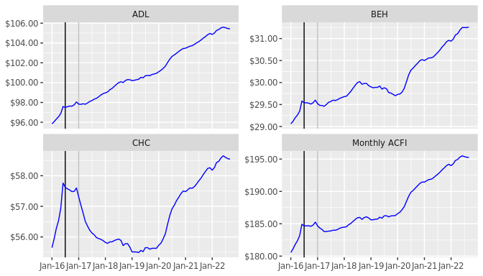

Table 2: Cumulative Daily Average ACFI Subsidies and Growth Rates by State

| State | July 2021 to Sep 2021 | July 2022 to Sep 2022 | Nominal growth | Real growth |
| --- | --- | --- | --- | --- |
| Projected National | $189.75 | $195.11 | 2.8% | 1.1% |
| Actual National | $189.75 | $195.30 | 2.9% | 1.2% |
| NSW | $186.73 | $193.09 | 3.4% | 1.7% |
| VIC | $194.65 | $198.97 | 2.2% | 0.5% |
| QLD | $188.39 | $195.43 | 3.7% | 2.0% |
| WA | $192.12 | $194.71 | 1.3% | -0.3% |
| SA | $188.48 | $194.43 | 3.2% | 1.4% |
| TAS | $186.15 | $191.43 | 2.8% | 1.1% |
| ACT | $186.41 | $191.72 | 2.8% | 1.1% |
| NT | $194.87 | $196.58 | 0.9% | -0.8% |

Table 3: Cumulative Daily Average ACFI Subsidies and Growth Rates by Remoteness

| Remoteness | July 2021 to Sep 2021 | July 2022 to Sep 2022 | Nominal growth | Real growth |
| --- | --- | --- | --- | --- |
| Major Cities | $193.16 | $198.50 | 2.8% | 1.0% |
| Inner Regional | $183.44 | $189.37 | 3.2% | 1.5% |
| Outer Regional | $178.41 | $184.35 | 3.3% | 1.6% |
| Remote | $156.13 | $166.62 | 6.7% | 4.9% |
| Very Remote | $161.07 | $163.70 | 1.6% | -0.1% |

Table 4: Cumulative Daily Average ACFI Subsidies and Growth Rates by Organisation Type

| Organisation Type | July 2021 to Sep 2021 | July 2022 to Sep 2022 | Nominal growth | Real growth |
| --- | --- | --- | --- | --- |
| Not-for-profit | $186.19 | $191.67 | 2.9% | 1.2% |
| For-profit | $197.50 | $203.01 | 2.8% | 1.1% |
| Government | $159.81 | $163.88 | 2.5% | 0.8% |

Table 5: Cumulative Daily Average ACFI Subsidies and Growth Rates by Provider Size[2]

| Provider Size | July 2021 to Sep 2021 | July 2022 to Sep 2022 | Nominal growth | Real growth |
| --- | --- | --- | --- | --- |
| 0-39 | $163.59 | $167.16 | 2.2% | 0.5% |
| 40-74 | $177.75 | $181.66 | 2.2% | 0.5% |
| 75-129 | $181.63 | $186.94 | 2.9% | 1.2% |
| 130-499 | $187.73 | $192.03 | 2.3% | 0.6% |
| 500-999 | $193.97 | $198.79 | 2.5% | 0.8% |
| 1000+ | $194.52 | $201.14 | 3.4% | 1.7% |

Table 6: Cumulative proportion of total days by ACFI level and ACFI category

|  | ADL | | |  | BEH | | |  | CHC | | |
| --- | --- | --- | --- | --- | --- | --- | --- | --- | --- | --- | --- |
| ACFI Level | July 2021 to Sep 2021 | July 2022 to Sep 2022 | Change ADL |  | July 2021 to Sep 2021 | July 2022 to Sep 2022 | Change BEH |  | July 2021 to Sep 2021 | July 2022 to Sep 2022 | Change CHC |
| H | 66.3% | 68.4% | 2.1% |  | 66.6% | 68.5% | 1.9% |  | 56.5% | 58.3% | 1.8% |
| M | 26.7% | 25.6% | -1.1% |  | 21.8% | 21.0% | -0.8% |  | 30.5% | 29.4% | -1.1% |
| L | 6.7% | 5.7% | -1.0% |  | 8.6% | 7.9% | -0.7% |  | 12.6% | 11.9% | -0.7% |
| N | 0.3% | 0.2% | -0.1% |  | 3.0% | 2.6% | -0.4% |  | 0.4% | 0.4% | -0.0% |

Table 7: Cumulative proportion of total days by ADL Scores and ADL Question

|  | July 2021 to Sep 2021 | | | |  | July 2022 to Sep 2022 | | | |
| --- | --- | --- | --- | --- | --- | --- | --- | --- | --- |
| ADL Question | A | B | C | D |  | A | B | C | D |
| Nutrition | 1.7% | 9.7% | 74.6% | 14.0% |  | 1.3% | 8.6% | 77.0% | 13.1% |
| Mobility | 0.9% | 1.3% | 29.9% | 67.8% |  | 0.8% | 1.1% | 28.6% | 69.5% |
| Personal Hygiene | 0.2% | 3.7% | 7.5% | 88.6% |  | 0.2% | 3.2% | 7.3% | 89.4% |
| Toileting | 1.3% | 7.0% | 15.2% | 76.6% |  | 1.0% | 6.2% | 15.0% | 77.7% |
| Incontinence | 8.2% | 1.5% | 3.0% | 87.3% |  | 7.1% | 1.3% | 2.8% | 88.8% |

Table 8: Cumulative proportion of total days by BEH scores and BEH question

|  | July 2021 to Sep 2021 | | | |  | July 2022 to Sep 2022 | | | |
| --- | --- | --- | --- | --- | --- | --- | --- | --- | --- |
| BEH Question | A | B | C | D |  | A | B | C | D |
| Cognitive skills | 6.0% | 26.9% | 39.9% | 27.1% |  | 5.7% | 26.7% | 40.8% | 26.9% |
| Wandering | 87.6% | 3.9% | 3.0% | 5.6% |  | 88.3% | 3.7% | 2.9% | 5.2% |
| Verbal | 10.0% | 11.3% | 20.7% | 58.0% |  | 9.1% | 11.0% | 21.0% | 58.9% |
| Physical | 25.4% | 16.3% | 21.0% | 37.3% |  | 23.9% | 16.4% | 21.9% | 37.7% |
| Depression | 32.1% | 29.5% | 19.8% | 18.6% |  | 32.2% | 29.0% | 20.0% | 18.8% |

Table 9: Distribution of claim days for the CHC

**July 2021 to Sep 2021**

Appraised before 1 July 2016

|  | Q12 | | | |  | | |
| --- | --- | --- | --- | --- | --- | --- | --- |
| Q11 | A | B | C | D |  | Rating | Proportion |
| A | 0.0% | 0.0% | 0.1% | 0.0% |  | Nil | 1.0% |
| B | 0.0% | 0.1% | 0.3% | 0.8% |  | Low | 6.0% |
| C | 0.1% | 0.1% | 0.3% | 1.1% |  | Med | 15.5% |
| D | 0.1% | 0.3% | 2.3% | 0.7% |  | High | 77.5% |

Appraised between 1 July 2016 and 31 December 2016

|  | Q12 | | | |  | | |
| --- | --- | --- | --- | --- | --- | --- | --- |
| Q11 | A | B | C | D |  | Rating | Proportion |
| A | 0.0% | 0.0% | 0.0% | 0.0% |  | Nil | 0.6% |
| B | 0.0% | 0.0% | 0.1% | 0.5% |  | Low | 5.4% |
| C | 0.0% | 0.0% | 0.1% | 0.5% |  | Med | 22.6% |
| D | 0.0% | 0.1% | 0.1% | 0.5% |  | High | 71.3% |

Appraised after 1 January 2017

|  | Q12 | | | |  | | |
| --- | --- | --- | --- | --- | --- | --- | --- |
| Q11 | A | B | C | D |  | Rating | Proportion |
| A | 0.3% | 0.1% | 0.4% | 0.3% |  | Nil | 0.4% |
| B | 7.4% | 4.3% | 27.8% | 45.7% |  | Low | 13.2% |
| C | 0.0% | 0.5% | 0.5% | 4.5% |  | Med | 31.7% |
|  |  |  |  |  |  | High | 54.7% |

**July 2022 to Sep 2022**

Appraised before 1 July 2016

|  | Q12 | | | |  | | |
| --- | --- | --- | --- | --- | --- | --- | --- |
| Q11 | A | B | C | D |  | Rating | Proportion |
| A | 0.0% | 0.0% | 0.0% | 0.0% |  | Nil | 1.1% |
| B | 0.0% | 0.1% | 0.2% | 0.6% |  | Low | 5.9% |
| C | 0.1% | 0.0% | 0.2% | 0.7% |  | Med | 14.9% |
| D | 0.0% | 0.2% | 1.6% | 0.5% |  | High | 78.1% |

Appraised between 1 July 2016 and 31 December 2016

|  | Q12 | | | |  | | |
| --- | --- | --- | --- | --- | --- | --- | --- |
| Q11 | A | B | C | D |  | Rating | Proportion |
| A | 0.0% | 0.0% | 0.0% | 0.0% |  | Nil | 0.5% |
| B | 0.0% | 0.0% | 0.1% | 0.3% |  | Low | 4.5% |
| C | 0.0% | 0.0% | 0.1% | 0.3% |  | Med | 21.0% |
| D | 0.0% | 0.1% | 0.1% | 0.3% |  | High | 74.0% |

Appraised after 1 January 2017

|  | Q12 | | | |  | | |
| --- | --- | --- | --- | --- | --- | --- | --- |
| Q11 | A | B | C | D |  | Rating | Proportion |
| A | 0.3% | 0.1% | 0.4% | 0.3% |  | Nil | 0.4% |
| B | 7.2% | 4.0% | 27.2% | 49.3% |  | Low | 12.3% |
| C | 0.0% | 0.5% | 0.5% | 4.6% |  | Med | 30.2% |
|  |  |  |  |  |  | High | 57.1% |

Table 10: Actual Average ACFI per day - Monthly and Cumulative

| ACFI | Jul 22 | Aug 22 | Sep 22 | Oct 22 | Nov 22 | Dec 22 |
| --- | --- | --- | --- | --- | --- | --- |
| Monthly ACFI | $195.38 | $195.28 | $195.23 |  |  |  |
| Cumulative ACFI | $195.38 | $195.33 | $195.30 |  |  |  |
| ACFI | Jan 23 | Feb 23 | Mar 23 | Apr 23 | May 23 | Jun 23 |
| Monthly ACFI |  |  |  |  |  |  |
| Cumulative ACFI |  |  |  |  |  |  |

Figure 3. ACFI Category - Change in Proportion of Total Care Days Year to Date – Year on Year[3]

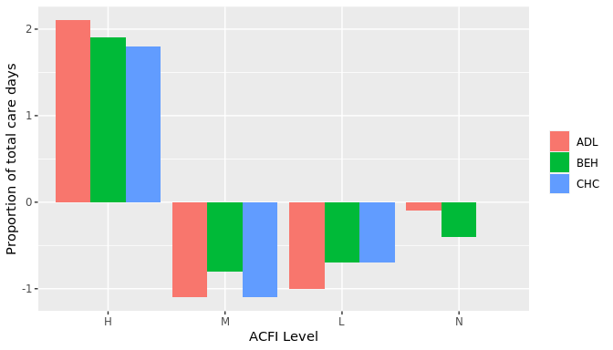

1. All $ values are based on ACFI Question Responses and calculated at 2022/23 ACFI rates.
2. Based on full time equivalent residents per year for 2021/22. Only includes providers active during July 2022.
3. Compares change in proportion of care days for start of July to end of September between 2021/22 and 2022/23.